Derwent Primary School Newsletter
Our value for July is: Happiness and Joy

Dear parents and carers,
Firstly, a huge thank you to the PTA for such a successful summer fair. It really was a hard decision as to whether or not to keep it going due to the hot weather, but I am so pleased that we did and it was a wonderful event. Thank you to the PTA for all of their efforts with this and to all of you who came to help raise money for the school. All funds raised go back into the enrichment of the school for the benefit of all of our children.
This week saw the rescheduled year 2 trip to Woburn, thank you again to the staff for organising this and to the parents who gave up their time to join them. Miss Kell received feedback from zoo staff about how wonderful our children were! We have had sharing assemblies- well done to pre-school, reception, year 2 and voles class from year 3. These were fantastic end of year events. Years 4 and 5 had their music assemblies for parents and showed off their skills in P Bones and Ukuleles. And finally the year 6 pupils had their residential trip to the Caldecotte Experience in Milton Keynes. A massive thank you to the staff for volunteering to attend this trip, without their willingness these trips could not go ahead and I know the pupils and parents were so appreciative. The children had the best time taking part in all of the activities. The children in year 6 who did not attend the residential trip enjoyed an activities week in school organised by Mrs Harris and they too had the best week of bowling, cooking, picnics and parks. A big thank you to Mrs Harris for organising all of this too.
Today, all pupils got the opportunity to meet their new teachers and spend the day in their classrooms. They took part in many getting to know you activities and had a great time meeting some new faces of pupils who will be joining us in September.
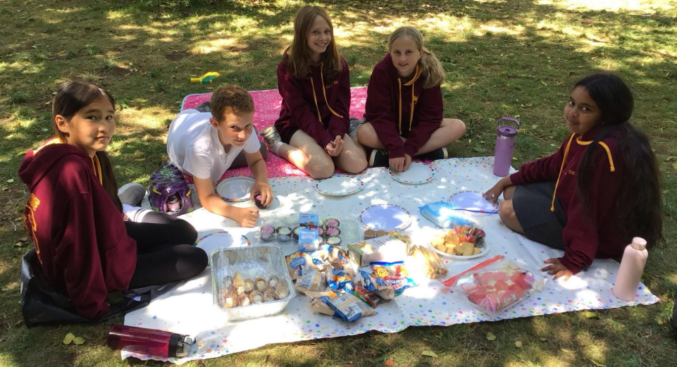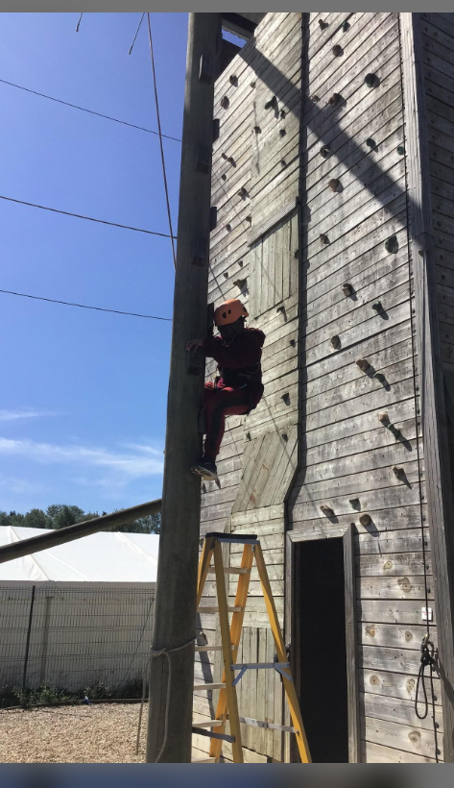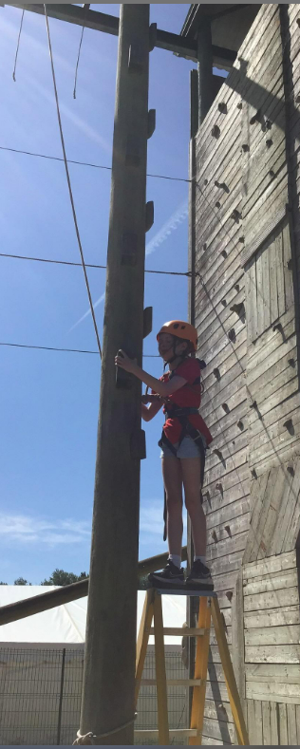
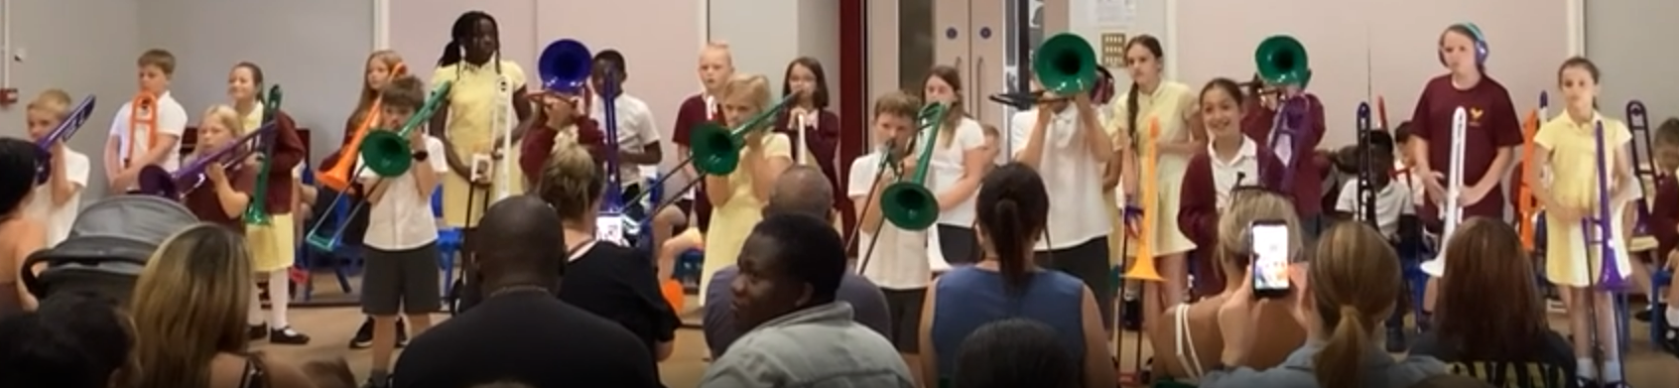
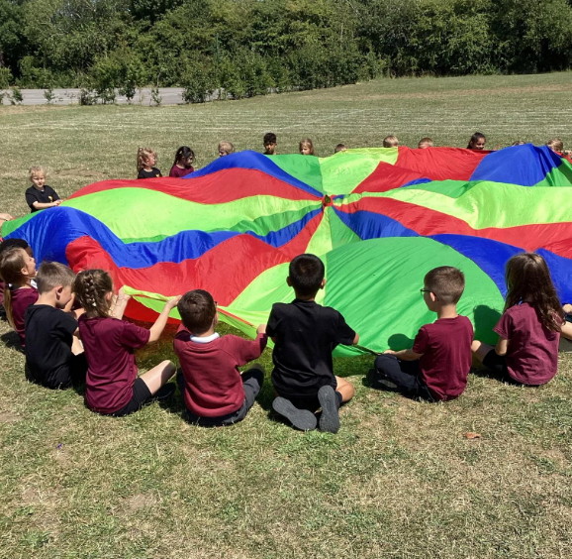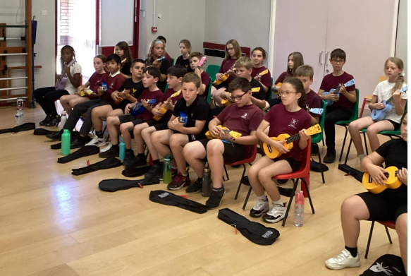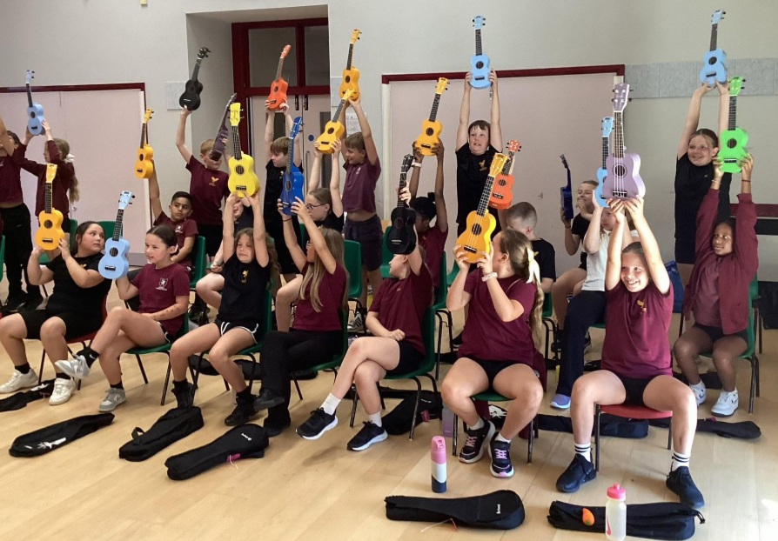
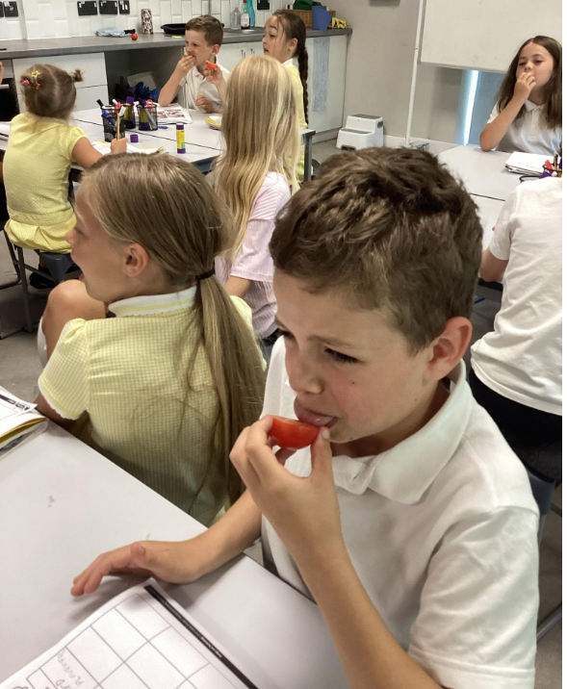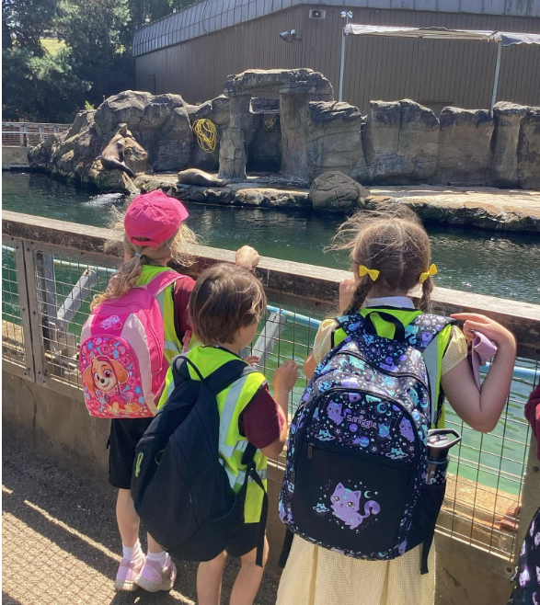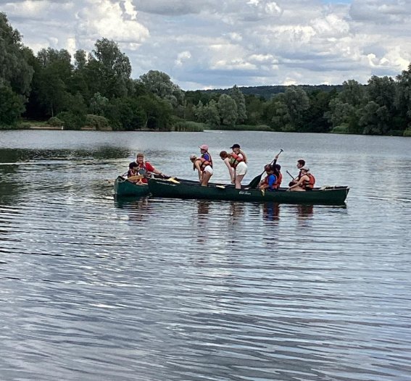
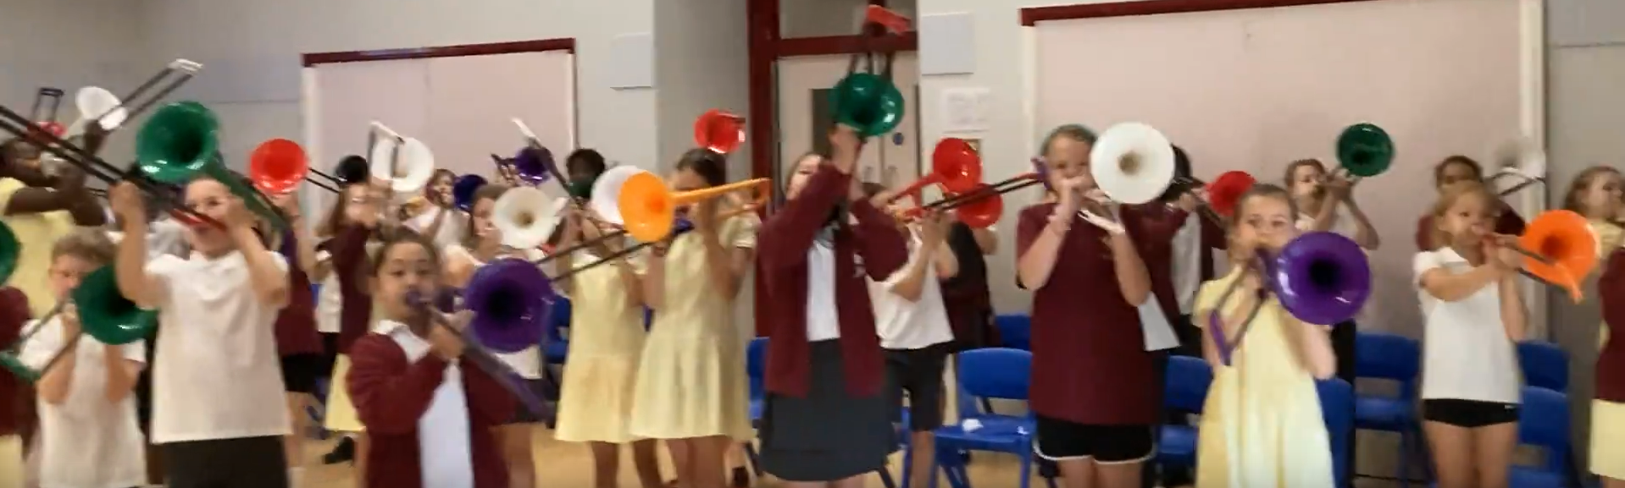School Calendar :
Keep an eye out on the Dojo calendar for updates on school and PTA events in the future. We have recently sent out dates for sports events and end of year performances to parents.
Word of the Week for the week:
For EYFS:
Vine
For KS 1 and KS 2:
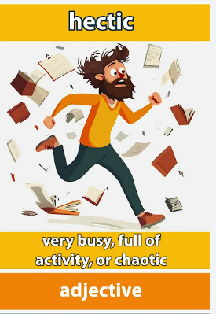
Hectic (adjective)
Meaning busy and rushing from one activity to the next.

This word is perfect for a school environment at this time of year.

Sign of the Week:
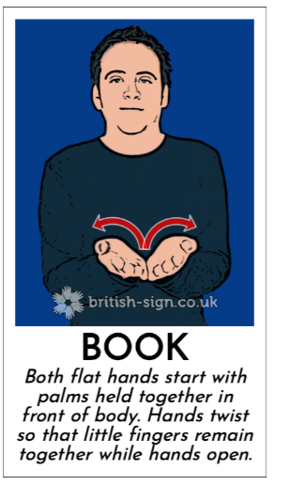
School Uniform Reminders:
Please remember you can order from the new website for school uniform: https://derwent-school-uniform.sumupstore.com/
Other key bits of information
- Please ensure pupils have the correct school uniform and PE kit. We do have quite a stock of second hand uniform if required – please ask at the school office about this.
- Please remember summer uniform is now permitted. This can be the usual school skirts / trousers or shorts with a white polo shirt or the yellow gingham dress / skirt / shorts.
- Please do remember water bottles. Please ensure all are labelled.
- Please ensure you speak to a member of staff if you have concerns and do not address these yourself with children or parents on the school playground. This can lead to conflict and unnecessary responses. We are here to help.
- School lunches continue to be provided by AIP. Please use the school Food United app to order all meals by 8am on the day otherwise the meal of jacket potato and beans will be served.
- Please ensure you have booked and paid for all WAC sessions, Pre-School lunch sessions and chargeable sessions via Arbor in advance.
As always, if you have any concerns, questions or issues, please do contact the office or SLT.
Have a wonderful weekend!

Mrs Rimmer Head of School and the leadership team.


Derwent Primary School Safeguarding
safeguarding@derwentschool.co.uk

Safeguarding Lead: Mrs Samantha Barlow
Deputy Safeguarding Lead: Mrs Tenille Rimmer, Mrs Chloe Bell, Mrs Sonya Read, Miss Hayley Kell and Mr Callum Masterson
Safeguarding Governor: W.O. Sarah Tuckwell

Do you have any safeguarding concerns regarding a child? If so, please feel free to contact any of the above in confidence via the email address at the top. This email is accessible by the above members of staff only.

 Star Awards
Ladybirds: Evan
Caterpillars: Lyra
Hedgehogs: Alyssa
Squirrels: Luella
Rabbits: Luca
Hares: Milo
Owls: Austin
Ravens: Fraser
Mice: Mia
Voles: Harrison
Foxes: Whole Class
Wildcats: Grace
Harriers: Oscar
Kestrels: Jake
Eagles: Whole Class
Hawks: Alfie-Jon
Certificates will go home with the children today

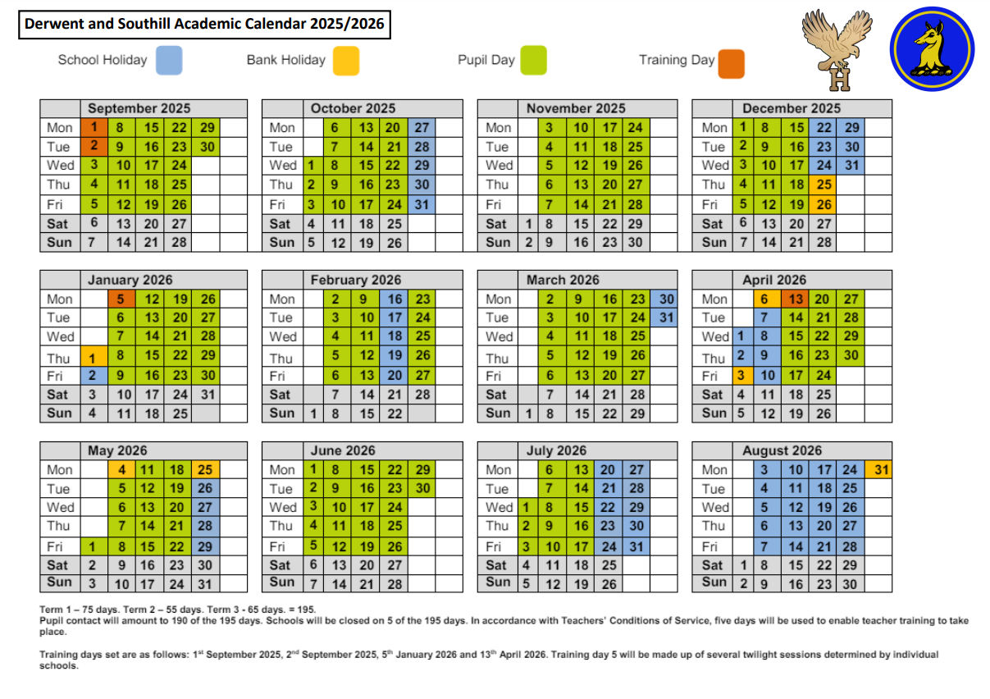
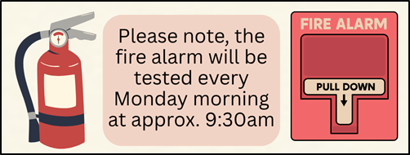






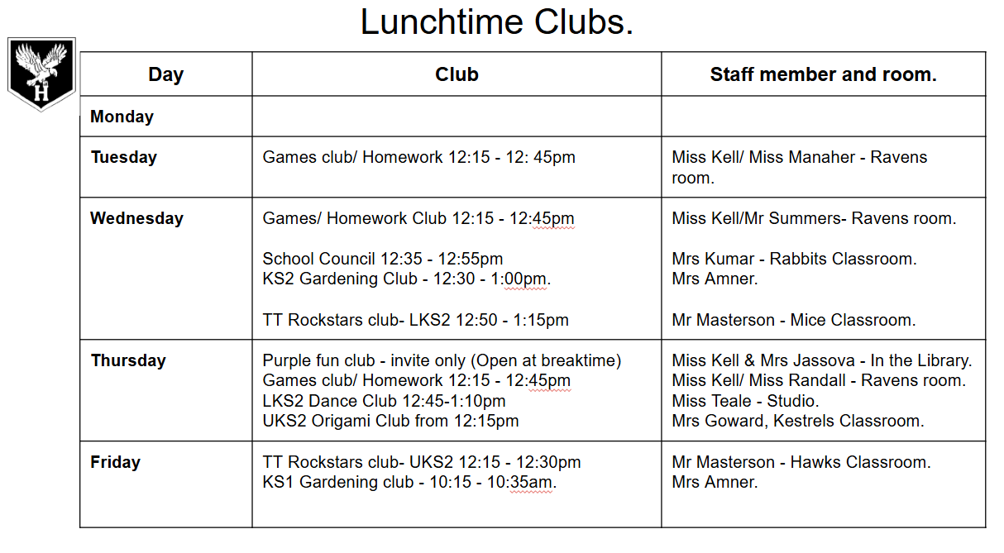

Dates for your diary *Please check here regularly for added dates throughout the year*
Dates for your 2025/26 diary
July
6th July – Reception Sports Morning
7th July – KS2 Sports Morning
9th July – KS1 Sports Morning
9th July – Yr 6 J Sax Performance
9th July – Drama Show for Parents
10th July – Pre School sports morning (10-11)
15th July – Yr6 Bowling Trip
15th July – Rocksteady Summer concert
16th July – Leavers Production Hawks & Eagles
17th July – Last day of School (Optional collection from 2pm)
September
3rd September – Inset Day
4th September – Inset Day
7th September – All Children back to school

Why not look at the full calendar on the school website (https://www.derwentschool.co.uk/Calendar/). Here you will find what we have planned for the 2025/2026 Academic Year.

Please read
Arbor
Dear Parents and Carers,
This is a gentle reminder to please ensure that you have booked and paid for your child’s wrap around care and pre-school lunch sessions for July 2026. If you are booking these on a monthly basis, please ensure you are thinking ahead to the next upcoming month and pre-booking with plenty of notice.
Please also note that your Arbor account balance should always be in credit – payments are to be made up front and not paid in arrears.

Break time Snacks
A gentle reminder that any snacks brought to school for break time need to be a healthy choice as per our food policy and nut free. Please see below the snack section from the policy:

Snacks:
- Children from Pre-School to year 2 are supplied with a healthy snack at break time, free of charge.
- All pupils are welcome to bring a healthy snack from home for their break, for example a piece of fruit, vegetable portion or healthy bar.

Please note that crisps, chocolate bars etc, are not to be consumed at break time. Also a reminder to all parents that we are a nut free school. This means no nuts or nut products are allowed in school. We respectfully ask for all parents' co-operation with this.
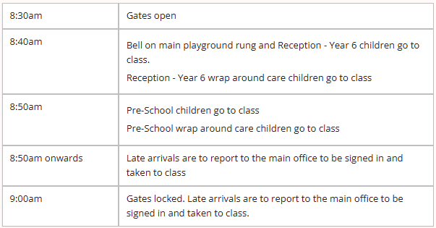
Morning drop off and afternoon pick up – reminder of times
Just a gentle reminder to please ensure that you are dropping your children at school on time.
Pre-school drop off is 8.50am and for children in Reception to Year 6 it is 8.40am.
We are seeing an increase in the number of children being dropped off much later than these times and on many occasions past 9am. We understand if there can sometimes be road closures, or traffic but this isn’t the case every day.
The office team is often disrupted from important tasks such as completing the school registers when they are having to take children who arrive late to their classroom.
We also request prompt collection at the end of the day at 3.20pm for pre-school and 3.30pm for children in Reception to Year 6.
Thank you for your cooperation.
WAC
Please kindly ensure that if you arrive to drop off at breakfast club before 7.30am and the gates to the car park are locked that you allow enough space for staff to be able to arrive and open the gates up.

After school club reminder
Just a gentle reminder that the after school club finishes at 5.45pm and so all children need to be collected promptly by this time. Late charges apply for any collections after 5.45pm.
Please also ensure that your child has all their belongings with them before they leave the club.

Vacancies at Derwent
We are advertising for a Clerk to join our team from September 2026. Please see link below to the vacancy should you or anyone you know be interested in applying for the position.
Clerk link – https://mynewterm.com/jobs/109457/EDV-2026-DPS-71793

